2025 Water Quality Report for City of Rose City
Water Supply Serial Number: 05815
This report covers the drinking water quality for City of Rose City for the 2024 calendar year. This information is a snapshot of the quality of the water that we provided to you in 2024. Included are details about where your water comes from, what it contains, and how it compares to United States Environmental Protection Agency (U.S. EPA) and state standards.
Your water comes from two groundwater wells, each over 80 feet. The State performed an assessment of our source water to determine the susceptibility or the relative potential of contamination. The susceptibility rating is on a seven-tiered scale from "very-low" to "very-high" based on geologic sensitivity, well construction, water chemistry and contamination sources. The susceptibility of our source is available at Rose City Hall or by calling (989) 685-2103 or by email at Rosecitydpw@gmail.com.
There are no significant sources of contamination in our water supply. We are making efforts to protect our sources by continuing our yearly and monthly sampling plan.
If you would like to know more about this report, please contact:
Rose City Hall 410 N. Williams St., Rose City, MI 48654 (989)685-2103
rosecityhall279@gmail.com
rosecitymich.com

Contaminants and their presence in water: Drinking water, including bottled water, may reasonably be expected to contain at least small amounts of some contaminants. The presence of contaminants does not necessarily indicate that water poses a health risk. More information about contaminants and potential health effects can be obtained by calling the U.S. EPA’s Safe Drinking Water Hotline (800-426-4791).
Vulnerability of sub-populations: Some people may be more vulnerable to contaminants in drinking water than the general population. Immuno-compromised persons such as persons with cancer undergoing chemotherapy, persons who have undergone organ transplants, people with HIV/AIDS or other immune systems disorders, some elderly, and infants can be particularly at risk from infections. These people should seek advice about drinking water from their health care providers. U.S. EPA/Center for Disease Control guidelines on appropriate means to lessen the risk of infection by Cryptosporidium and other microbial contaminants are available from the Safe Drinking Water Hotline (800-426-4791).
Sources of drinking water: The sources of drinking water (both tap water and bottled water) include rivers, lakes, streams, ponds, reservoirs, springs, and wells. Our water comes from wells. As water travels over the surface of the land or through the ground, it dissolves naturally-occurring minerals and, in some cases, radioactive material, and can pick up substances resulting from the presence of animals or from human activity.
Contaminants that may be present in source water include:
- Microbial contaminants, such as viruses and bacteria, which may come from sewage treatment plants, septic systems, agricultural livestock operations and wildlife.
- Inorganic contaminants, such as salts and metals, which can be naturally-occurring or result from urban stormwater runoff, industrial or domestic wastewater discharges, oil and gas production, mining or farming.
- Pesticides and herbicides, which may come from a variety of sources such as agriculture and residential uses.
- Radioactive contaminants, which can be naturally occurring or be the result of oil and gas production and mining activities.
- Organic chemical contaminants, including synthetic and volatile organic chemicals, which are by-products of industrial processes and petroleum production, and can also come from gas stations, urban stormwater runoff, and septic systems.
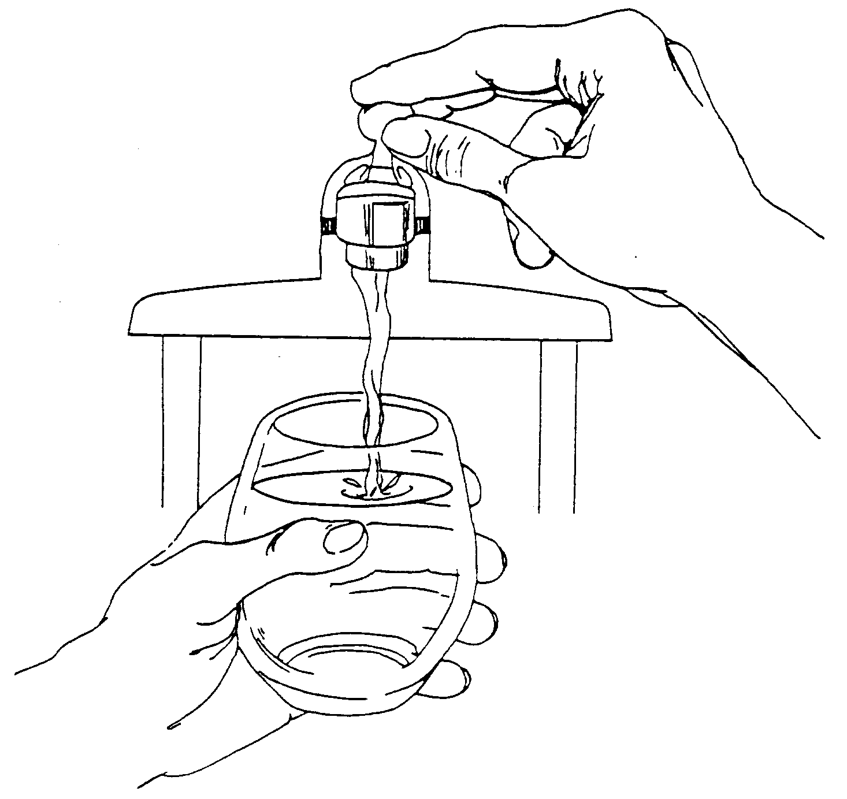
In order to ensure that tap water is safe to drink, the U.S. EPA prescribes regulations that limit the levels of certain contaminants in water provided by public water systems. Federal Food and Drug Administration regulations establish limits for contaminants in bottled water which provide the same protection for public health.

Water Quality Data
The table below lists all the drinking water contaminants that we detected during the 2024 calendar year. The presence of these contaminants in the water does not necessarily indicate that the water poses a health risk. Unless otherwise noted, the data presented in this table is from testing done January 1 through December 31, 2024. The State allows us to monitor for certain contaminants less than once per year because the concentrations of these contaminants are not expected to vary significantly from year to year. All the data is representative of the water quality, but some are more than one year old.

Terms and abbreviations used below:
- Maximum Contaminant Level Goal (MCLG): The level of a contaminant in drinking water below which there is no known or expected risk to health. MCLGs allow for a margin of safety.
- Maximum Contaminant Level (MCL): The highest level of a contaminant that is allowed in drinking water. MCLs are set as close to the MCLGs as feasible using the best available treatment technology.
- Maximum Residual Disinfectant Level (MRDL): The highest level of a disinfectant allowed in drinking water. There is convincing evidence that addition of a disinfectant is necessary for control of microbial contaminants.
- Maximum Residual Disinfectant Level Goal (MRDLG): The level of a drinking water disinfectant below which there is no known or expected risk to health. MRDLGs do not reflect the benefits of the use of disinfectants to control microbial contaminants.
- Treatment Technique (TT): A required process intended to reduce the level of a contaminant in drinking water.
- N/A: Not applicable
- ND: not detectable at testing limit
- ppm: parts per million or milligrams per liter
- ppb: parts per billion or micrograms per liter
- ppt: parts per trillion or nanograms per liter
- pCi/l: picocuries per liter (a measure of radioactivity)
- Action Level (AL): The concentration of a contaminant which, if exceeded, triggers treatment or other requirements that a water system must follow.
- Level 1 Assessment: A study of the water supply to identify potential problems and determine (if possible) why total coliform bacteria have been found in our water system.
- Level 2 Assessment: A very detailed study of the water system to identify potential problems and determine (if possible) why an E. coli MCL violation has occurred and/or why total coliform bacteria have been found in our water system on multiple occasions.

1Monitoring Data for Regulated Contaminants
Regulated Contaminant | MCL, TT, or MRDL | MCLG or MRDLG | Level Detected | Range | Year Sampled | Violation Yes/No | Typical Source of Contaminant
Arsenic (ppb) | 10 | 0 | 6 | 5-7 | 2025 | no | Erosion of natural deposits; Runoff from orchards; Runoff from glass and electronics production wastes
Nitrate (ppm) | 10 | 10 | N/D |  | 2025 | yes | Runoff from fertilizer use; Leaching from septic tanks, sewage; Erosion of natural deposits
TTHM Total Trihalomethanes (ppb) | 80 | N/A | N/D |  | 2025 | no | Byproduct of drinking water disinfection
HAA5 Haloacetic Acids (ppb) | 60 | N/A | N/D |  | 2025 | no | Byproduct of drinking water disinfection
Chlorine (ppm) | 4 | 4 | .85 | .11-1.58 | 2025 | no | Water additive used to control microbes
Total Coliform | TT | N/A | N/A | N/A | 2025 | no | Naturally present in the environment
E. coli in the distribution system (positive samples) | See E. coli note | 0 |  | N/A |  | no | Human and animal fecal waste
Fecal Indicator – E. coli at the source (positive samples) | TT | N/A |  | N/A |  | no | Human and animal fecal waste

Per- and polyfluoroalkyl substances (PFAS)
Regulated Contaminant | MCL, TT, or MRDL | MCLG or MRDLG | Level Detected | Range | Year Sampled | Violation Yes/No | Typical Source of Contaminant
Hexafluoropropylene oxide dimer acid (HFPO-DA) (ppt) | 370 | N/A | N/D |  | 2025 | NO | Discharge and waste from industrial facilities  utilizing the Gen X chemical process
Perfluorobutane sulfonic acid (PFBS) (ppt) | 420 | N/A | N/D |  | 2025 | NO | Discharge and waste from industrial  facilities; stain-resistant treatments
Perfluorohexane sulfonic acid (PFHxS) (ppt) | 51 | N/A | N/D |  | 2025 | NO | Firefighting foam; discharge and waste  from industrial facilities
Perfluorohexanoic acid (PFHxA) (ppt) | 400,000 | N/A | N/D |  | 2025 | NO | Firefighting foam; discharge and waste  from industrial facilities
Perfluorononanoic acid (PFNA) (ppt) | 6 | N/A | N/D |  | 2025 | NO | Discharge and waste from industrial  facilities; breakdown of precursor compounds
Perfluorooctane sulfonic acid (PFOS) (ppt) | 16 | N/A | N/D |  | 2025 | NO | Firefighting foam; discharge from electroplating facilities; discharge and waste  from industrial facilities
Perfluorooctanoic acid (PFOA) (ppt) | 8 | N/A | N/D |  | 2025 | NO | Discharge and waste from industrial  facilities; stain-resistant treatments
Inorganic Contaminant Subject to Action Levels (AL) | Action Level | MCLG | Your Water | Range of Results | Year Sampled | Number of Samples Above AL | Typical Source of Contaminant
Lead (ppb) | 15 | 0 | 1 | 0-1 | 2025 | 0 | Lead service lines, corrosion of household plumbing including fittings and fixtures; Erosion of natural deposits
Copper (ppm) | 1.3 | 1.3 | .07 | 0-.07 | 2025 | 0 | Corrosion of household plumbing systems; Erosion of natural deposits

Information about lead: Lead can cause serious health effects in people of all ages, especially pregnant people, infants (both formula-fed and breastfed), and young children. Lead in drinking water is primarily from materials and parts used in service lines and in home plumbing. [INSERT NAME OF SYSTEM] is responsible for providing high quality drinking water and removing lead pipes but cannot control the variety of materials used in the plumbing in your home. Because lead levels may vary over time, lead exposure is possible even when your tap sampling results do not detect lead at one point in time. You can help protect yourself and your family by identifying and removing lead materials within your home plumbing and taking steps to reduce your family's risk. Using a filter, certified by an American National Standards Institute accredited certifier to reduce lead, is effective in reducing lead exposures. Follow the instructions provided with the filter to ensure the filter is used properly. Use only cold water for drinking, cooking, and making baby formula. Boiling water does not remove lead from water. Before using tap water for drinking, cooking, or making baby formula, flush your pipes for several minutes. You can do this by running your tap, taking a shower, doing laundry or a load of dishes. If you have a lead service line or galvanized requiring replacement service line, you may need to flush your pipes for at least 5 minutes to flush water from both your home plumbing and the lead service line. If you are concerned about lead in your water and wish to have your water tested, contact Matt Lawrence 989-390-9009 for available resources. Information on lead in drinking water, testing methods, and steps you can take to minimize exposure is available at https://www.epa.gov/safewater/lead.
While your drinking water meets the U.S. EPA standard for arsenic, it does contain low levels of arsenic. The U.S EPA standard balances the current understanding of arsenic's possible health effects against the costs of removing arsenic from drinking water. The U.S. EPA continues to research the health effects of low levels of arsenic, which is a mineral known to cause cancer in humans at high concentrations and is linked to other health effects such as skin damage and circulatory problems.

Instructions to Water Supplier
- Source of the Water Delivered must include:
  - Type of Water: e.g., surface water, groundwater
  - Commonly used name, if any, and location of body or bodies of water.
  - If a source water assessment has been completed, then the CCR shall notify customers of the availability of the assessment information and means to obtain it. In addition, a supply is encouraged to highlight in the report significant sources of contamination in the source water area if the supply has that information readily available.
  - If the supply has received a source water assessment from EGLE, then the report shall include a brief summary of the supply’s susceptibility to potential sources of contamination.
- Under "Level Detected" and “Range”:
  - The CCR should contain the most recent data in the last five years.
  - In the “Level Detected” column:
    - enter the highest test result from the lab UNLESS a contaminant’s compliance is determined based on a running annual average. Then, list the highest running annual average or locational running annual average.
    - Enter the test result from the lab report for sodium, even if it was not detected.
  - In the “Range” column, enter the lowest to highest individual sample results such as "12-48" (if you sample more than once during the year OR from multiple locations).
- Under "Year Sampled," enter the year sampled (if earlier than the year covered by the report).
- Under "Violation Yes / No," enter "Yes" to indicate a violation of MCLs, MRDLs, or Treatment Techniques. You DO NOT need to put “Yes” in the table for monitoring or reporting violations.
- Summary of a Violation/Public Notice
You must still describe all violations below the table, which should include a description of the violation, the mandatory health effects language (from Table 1 of R 325.10405), and actions taken to address the violation.
  - If monitoring requirements were not met, explain the violation below the table such as:
During the monitoring period from _____ to _____, we did not take the required number of routine samples for [enter contaminant name]. This violation did not pose a threat to the quality of the drinking water. [FURTHER EXPLAIN WHAT HAPPENED, ACTIONS TAKEN TO REMEDY THE SITUATION, POTENTIAL HEALTH EFFECTS, AND STEPS TAKEN TO PREVENT ANOTHER VIOLATION.]
Mentioning a violation in the CCR does not count as meeting the Public Notice requirements, unless the report is directly delivered to all customers within the required Public Notice timeframe, all 10 public elements are included, and the Public Notice Certificate of Distribution is to EGLE within 10 days of distribution.
If using the CCR as a vehicle to distribute a Public Notice, the supply must directly deliver the CCR to every bill paying customer. As result, CCR waivers that allow small systems to post their CCR in one location or publish in a newspaper would no longer apply.
- If arsenic was detected above 5 ppb but at or below 10 ppb include the following:
While your drinking water meets the U.S. EPA standard for arsenic, it does contain low levels of arsenic. The U.S EPA standard balances the current understanding of arsenic's possible health effects against the costs of removing arsenic from drinking water. The U.S. EPA continues to research the health effects of low levels of arsenic, which is a mineral known to cause cancer in humans at high concentrations and is linked to other health effects such as skin damage and circulatory problems.
- If nitrate was detected above 5 ppm but below 10 ppm include the following:
Nitrate in drinking water at levels above 10 ppm is a health risk for infants of less than six months of age. High nitrate levels in drinking water can cause blue baby syndrome. Nitrate levels may rise quickly for short periods of time because of rainfall or agricultural activity. If you are caring for an infant, you should ask for advice from your health care provider.
- Reporting Sodium:
Sodium levels are required to be included in the contaminants table, even when sodium results are non-detect. There is no MCL/MCLG for sodium.
- For supplies with lead service lines (or service lines of unknown material), include the number of lead service lines, the number of service lines of unknown material, and the total number of service lines in the supply.
- Although it is not required to list the number of total coliform-positive samples, the number of E. coli-positive samples from the distribution system or raw wells must be included in the table.
- If a Level 1 Assessment or a Level 2 Assessment was required, include the following, as appropriate:
  - During the past year we were required to conduct [INSERT NUMBER OF LEVEL 1 ASSESSMENTS] Level 1 Assessment(s). [INSERT NUMBER OF LEVEL 1 ASSESSMENTS] Level 1 Assessment(s) were completed. In addition, we were required to take [INSERT NUMBER OF CORRECTIVE ACTIONS] corrective actions and we completed [INSERT NUMBER OF CORRECTIVE ACTIONS] of these actions.
  - During the past year [INSERT NUMBER OF LEVEL 2 ASSESSMENTS] Level 2 Assessments were required to be completed for our water supply. [INSERT NUMBER OF LEVEL 2 ASSESSMENTS] Level 2 Assessments were completed. In addition, we were required to take [INSERT NUMBER OF CORRECTIVE ACTIONS] corrective actions and we completed [INSERT NUMBER OF CORRECTIVE ACTIONS] of these actions.
- If a Level 1 Assessment or a Level 2 Assessment was required but not completed, or the identified sanitary defects were not corrected, include the following, as appropriate:
During the past year we failed to conduct all the required assessment(s).
During the past year we failed to correct all identified defects that were found during the assessment.
- If a Level 1 Assessment or a Level 2 Assessment was required that was not due to an E. coli MCL violation, include the following:
Coliforms are bacteria that are naturally present in the environment and are used as an indicator that other, potentially harmful, waterborne pathogens may be present or that a potential pathway exists through which contamination may enter the drinking water distribution system. We found coliforms, indicating the need to look for potential problems in water treatment or distribution. When this occurs, we are required to conduct assessment(s) to identify problems and to correct the problems that were found during these assessments.
- If a Level 2 Assessment was required due to a E. coli MCL violation, include the following:
E. coli are bacteria whose presence indicates that the water may be contaminated with human or animal wastes. Human pathogens in these wastes can cause short-term effects such as diarrhea, cramps, nausea, headaches, or other symptoms. They may pose a greater health risk for infants, young children, the elderly, and people with severely compromised immune systems. We found E. coli bacteria, indicating the need to look for potential problems in water treatment or distribution. When this occurs, we are required to conduct assessment(s) to identify problems and to correct the problems that were found during these assessments.
We were required to complete a Level 2 Assessment because we found E. coli in our water system. In addition, we were required to take [INSERT NUMBER OF CORRECTIVE ACTIONS] corrective actions and we completed [INSERT NUMBER OF CORRECTIVE ACTIONS] of these actions.
- If E. coli was detected and the E. coli MCL was violated, include the following, as appropriate:
  - We had an E. coli-positive repeat sample following a total coliform-positive routine sample.
  - We had a total coliform-positive repeat sample following an E. coli-positive routine sample.
  - We failed to take all required repeat samples following an E. coli-positive routine sample.
  - We failed to test for E. coli when a repeat sample tests positive for total coliform.
- If the groundwater supply has any uncorrected significant deficiency, as designated by EGLE, or fecal indicator positive source sample result during the year, include the following elements:
  - Nature of the significant deficiency or source of the fecal contamination, if known, and the date(s).
  - Whether the fecal contamination has been addressed and date addressed.
  - For unaddressed significant deficiencies and unaddressed fecal contamination, the approved plan and schedule for correction, including interim measures, and progress to date.
  - The potential health effects of the fecal indicator positive source sample.

These instructions are meant to be a guide for water systems as they create their annual consumer confidence report. It is the responsibility of the water supply to ensure that their annual CCR is complete and accurate according to the safe drinking water rule prior to distribution. For additional assistance or questions please contact EGLE.

The chlorine “Level Detected” was calculated using a running annual average.
E. coli MCL violation occurs if: (1) routine and repeat samples are total coliform-positive and either is E. coli-positive, or (2) the supply fails to take all required repeat samples following E. coli-positive routine sample, or (3) the supply fails to analyze total coliform-positive repeat sample for E. coli.
Ninety (90) percent of the samples collected were at or below the level reported for our water.

